Project Title: IoT Based Safety Gadget for Child Safety Project Design Phase-I Solution- n Fit Template Team ID: PNTIBMCL12 Monitoring and Notification

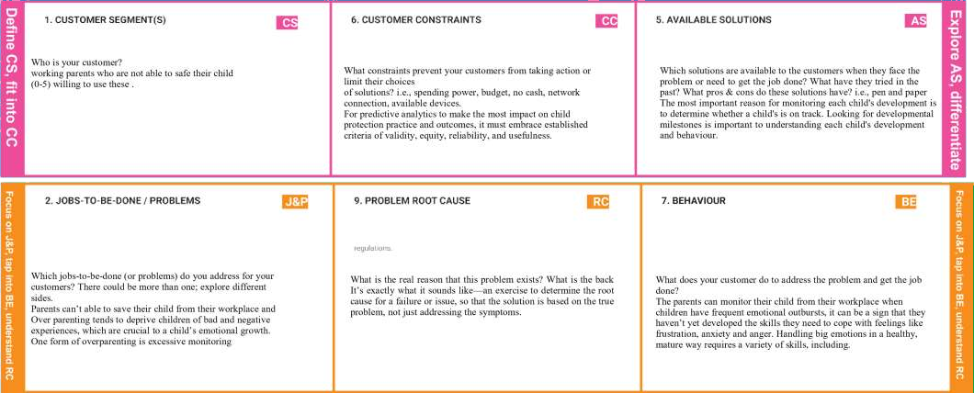

|  |  |  |  |  |  |
| --- | --- | --- | --- | --- | --- |
|  | **3. TRIGGERS T**  What triggers customers to act?  i.e., seeing their neighbour installing solar panels, reading about a more efficient solution in the news.  It’s not the situation or the feeling that’s the problem; it’s how kids think about these things and what they say to themselves that causes problems and child (0-2) years didn’t know about  anything this will trigger | **10. YOUR SOLUTION** | **S** | **8.CHANNELS of BEHAVIOUR C** |  |
|  |  | **8.1 ONLINE** |
| If you are working on an existing business, write down your current solution first, fill in the canvas, and check how much it fits reality.  If you are working on a new business proposition, then keep it blank until you fill in the canvas and come up with a solution that |  | What kind of actions do customers take online? Extract online channels from #7  **8.2 OFFLINE** |

|  |  |  |  |  |
| --- | --- | --- | --- | --- |
|  | **4. EMOTIONS: BEFORE / AFTER EM**  How do customers feel when they face a problem or a job and afterwards? i.e., lost, insecure > confident, in control - use it in your communication strategy & design.  BEFORE: Divergent thinking is a style of thinking that generates a range of alternative solutions or ideas to a problem that has multiple answers. AFTER: Feeling protective of your child is often manifested in the form of ‘motherly’ instincts. The feeling of protecting and wanting the best for  your children is the ultimate parenting goal | fits within customer limitations, solves a problem and matches customer behaviour.   * The most important reason for monitoring each child’s activities is to determine whether a child's activities is on track. Using ultrasonic sensor sense something near child and activate pieze buzz and SMS and dialing function to parents will be done immediately. | What kind of actions do customers take offline? Extract offline channels from #7 and use them for customer development.  Understanding how children perceive and interact with the point of sale has been the focus of various studies in the past decade. It is well documented that children have preferences in terms of shopping destinations .For working parents necessarily needed one. |  |